

In partnership with

Prepared by: Jo Wilkinson Date: 18th June 2018
Tel No.: 0115 9772947
Fax No.: 0115 9773614
Roadworks Bulletin – Rushcliffe Area
Temporary Speed Restriction and Road Closure –
Main Road, Cotgrave, Holme Lane, Holme Pierrepont and Holme Lane, Radcliffe on Trent
Road No. & Location | - Speed Restriction from 60mph to 30mph  Main Road, Cotgrave – between its junctions with Stragglethorpe Road, Stragglethorpe and Fields View, Cotgrave  - Road Closure  Holme Lane, Radcliffe on Trent – from a point 280 metres west of its junction with The Green in a westerly direction to its junction with Holme Lane, Holme Pierrepont.  Holme Lane, Holme Pierrepont – from its junction with Holme Lane, Radcliffe on Trent in a westerly direction for a distance of 400 metres.
Dates/Times | - 07.30 hours Monday 30th July 2018 until 17.00 hours Friday 26th October 2018  - 07.30 hours Monday 30th August 2018 until 17.00 hours Friday 24th August 2018
Carried out by | NMC Nomenca (A division of North Midland Construction plc)  on behalf of Severn Trent Water Ltd.
Nature of Restriction | Temporary 30 Mph Speed Limit and Temporary Road Closure
Nature of Works | Installation of a new sewer works
Alternative Route | Holme Lane, Holme Pierrepont and Holme Lane, Radcliffe on Trent - The Green, Radcliffe on Trent – Main Road, Radcliffe on Trent – Nottingham Road, Radcliffe on Trent – Radcliffe Road (A52) – Regatta Way, Gamston – Adbolton Lane, Holme Pierrepont and vice versa  Main Road, Cotgrave - N/A
Enquires | Craig Whittle - NMC Nomenca  07970 136553
Emergency Contact | Matt Brown – 07968 766650

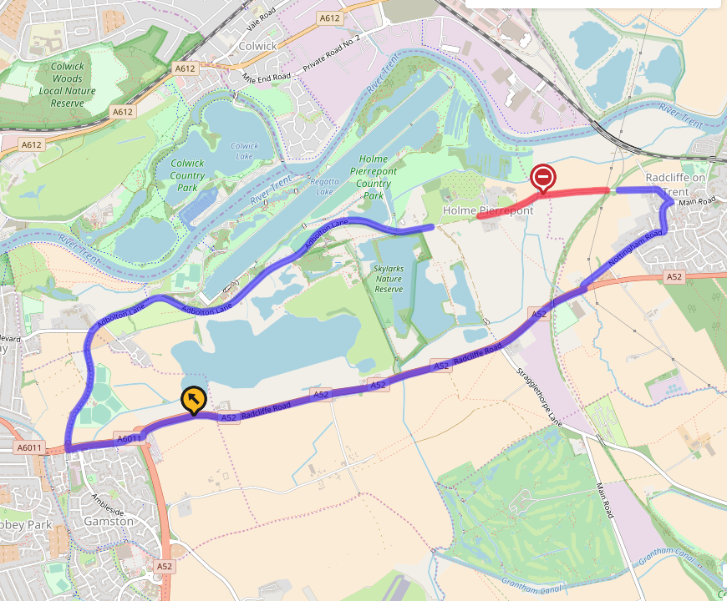
(Ref: R18-037 Advanced Roadworks Bulletin)


